JackcaD 2024 PROGRAM MANUAL

- ABOUT JACKCAD

This program is a calculation and drawing program that includes:
- Topography Calculation (Levelling, Polygon)
- Topographic Drawing (polygon, cross, situation, cross section, long section and its completeness)

Calculation of canal hydraulics
- Canal design (Cross Section, Long Section, Canal Alignment, Calculation of water level using standard step method and volume of work)
- Drawing of Structures (off take, boxes, drop, culverts, syphons and standard structures)
- Auxiliary programs to support completeness and ease of depiction
- Structure calculation

Work Volume Calculation
All program inputs are in Excel and outputs are in CAD and Excel formats.
The program is divided into three sections: Topography, Canal Design and Waterworks.
To make it easier to use Jackcad 2024, it is supported by the HeriAds program that runs in Excel.

- JackCAD2024 and HeriAds PROGRAM INSTALLATION
- Download JackCAD-HeriAds_Installer.zip from website https://jackc a d.com
- Open
- Extract JackCAD-HeriAds_Installer.
- Running Installer.exe
- The program will be located in c:Jackcad2024 and is ready to use.

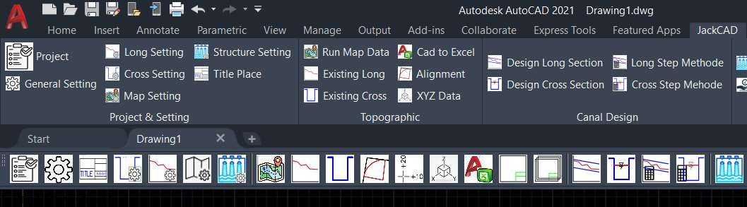
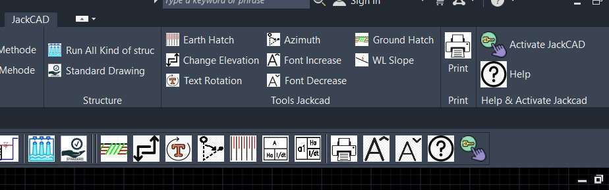
Jackcad2024 menu after installation

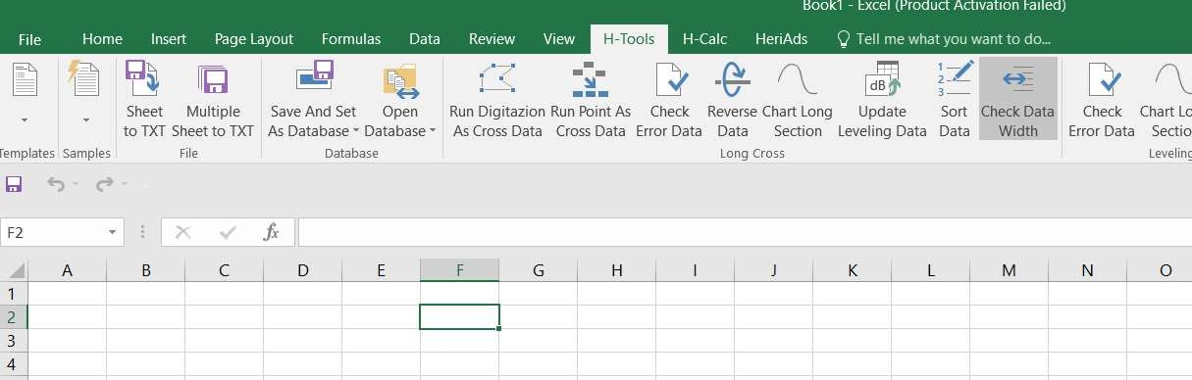
Excel menu will expand with H-Tools, HCalc and HeriAds

  - PROGRAM ACTIVATION
The Jackcad program can be activated by filling out the activation form through the Activate Jackcad icon and will be connected to the website for ordering. After the request code is received, the activation code will be sent to be entered in the dialog box.

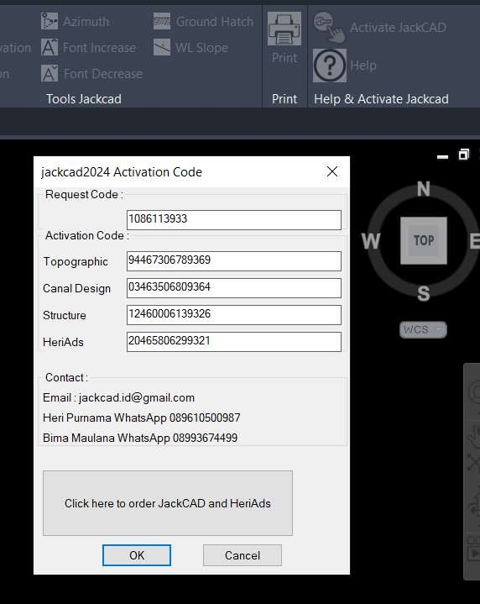

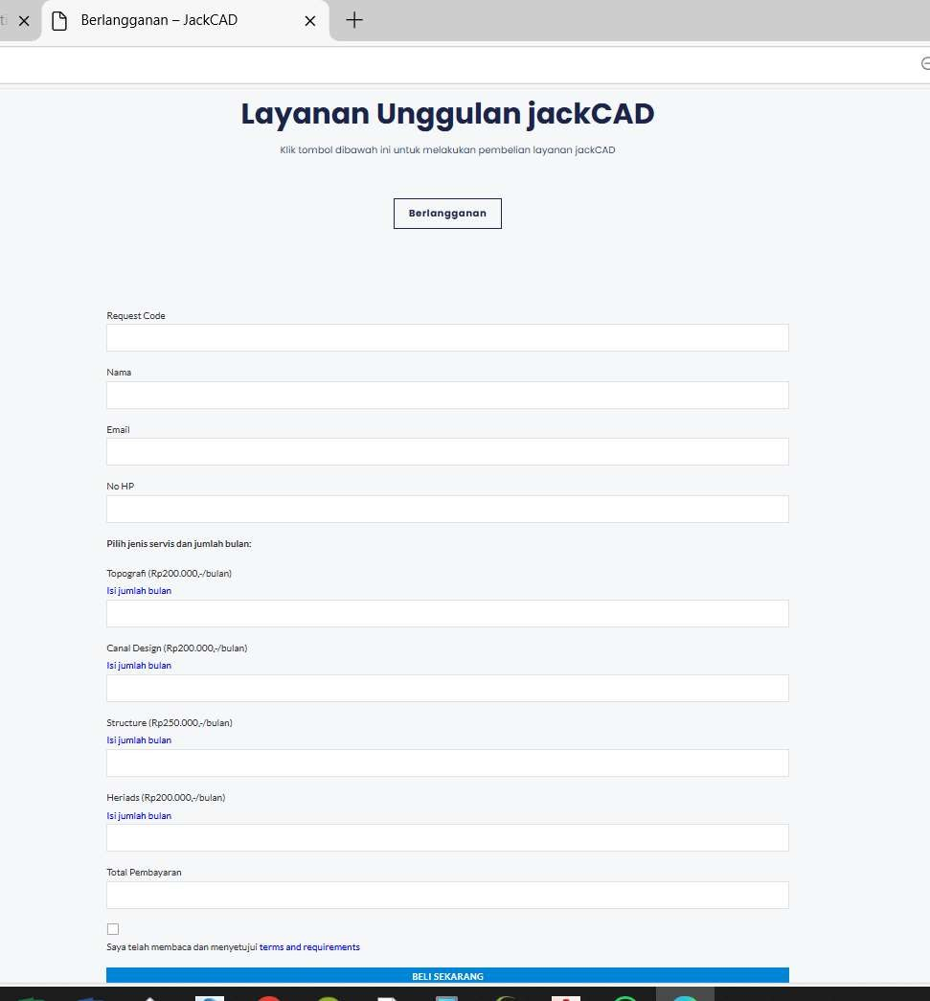
Enter the Request code number into the form and other information to send the activation code.

- PROJECT and SETTING

This program is prepared to work on several jobs with different settings so that to move from one job to another there is no need to change the settings continuously every time you change from one job to another.
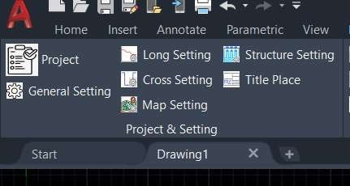
Project & Setting Panel
The steps to create a project are as follows:
- Select/Add/Edit a project with the JackCad2024 menu→ Project (or select the project icon), select as desired.

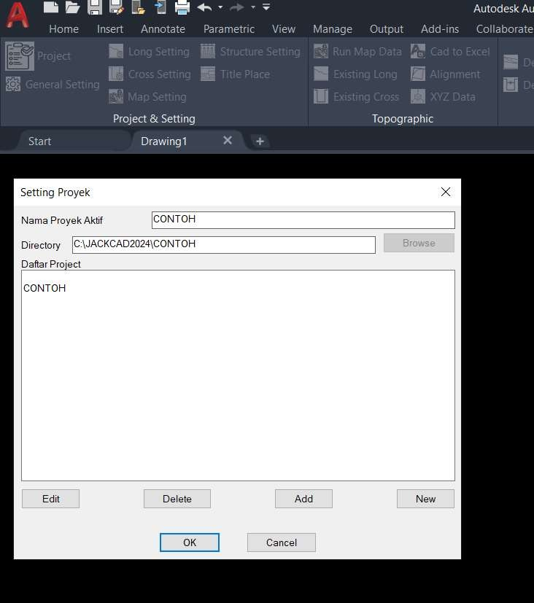

  - PROJECT SETTING

Project settings can be made different for each project so that when entering a particular project, the settings do not need to be changed again. Project settings in the form of header templates, longitudinal cut sheets, cubication, scale line shapes etc. can be changed directly by opening the dwg file in the project directory that is run in the Settings folder→ (Project)/Setting as in the following example:

    - TITLE LOCATION
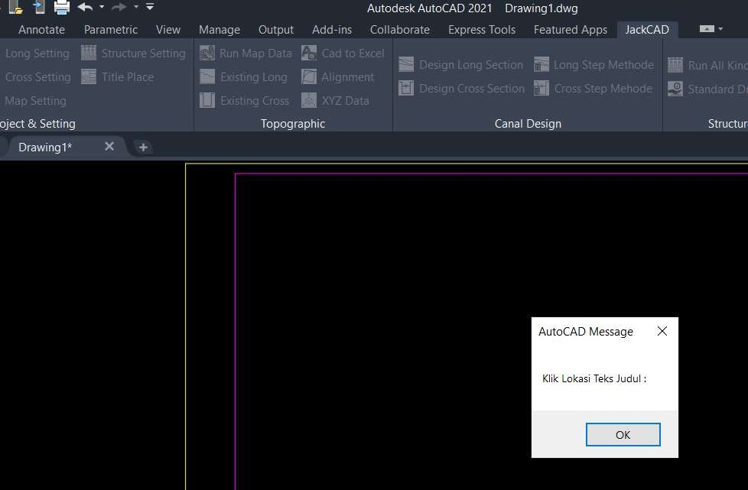
Click Title Place then click the title location, sheet number and register number.
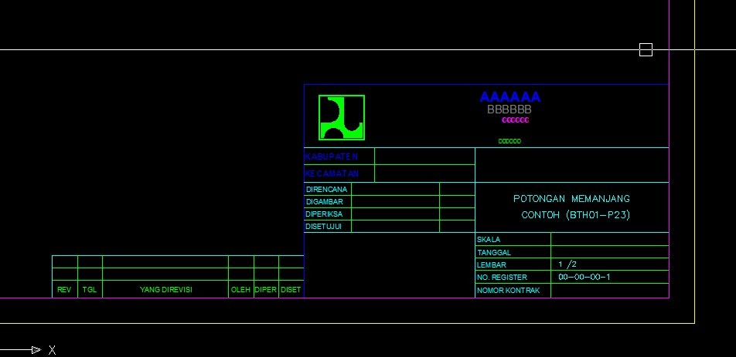

    - General Setting
The general settings for situation, long and cross can be opened from the general settings menu.

    - Option Setting Long, Cross, Situation
In addition to general settings, there are special settings for Long section, Cross section and Situation that can be adjusted as needed.

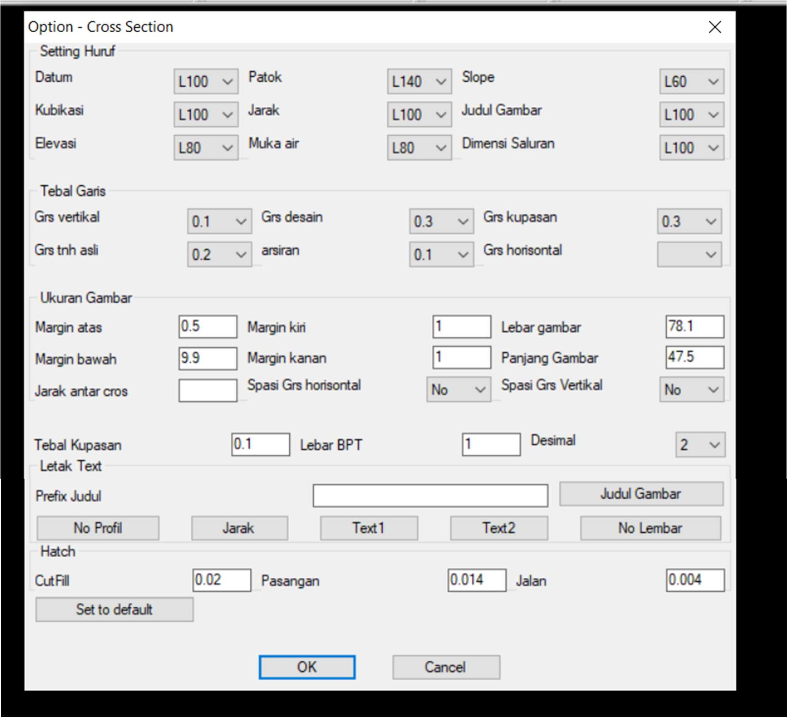

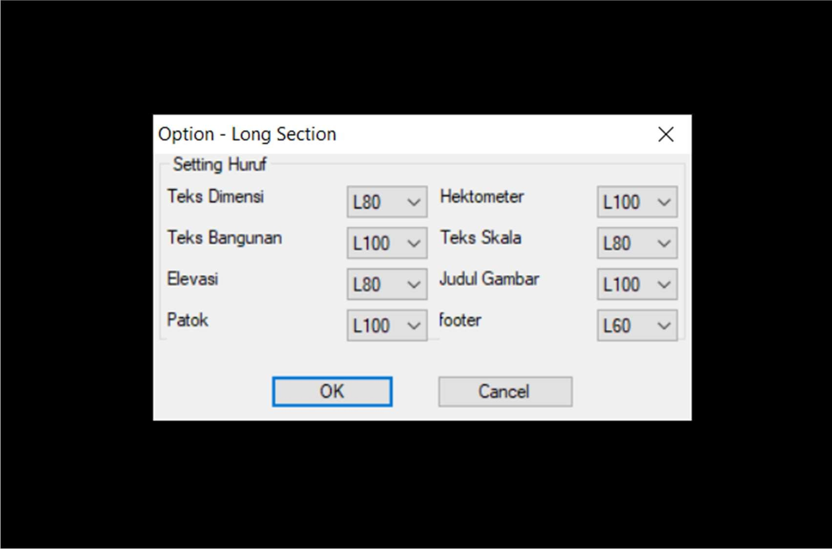

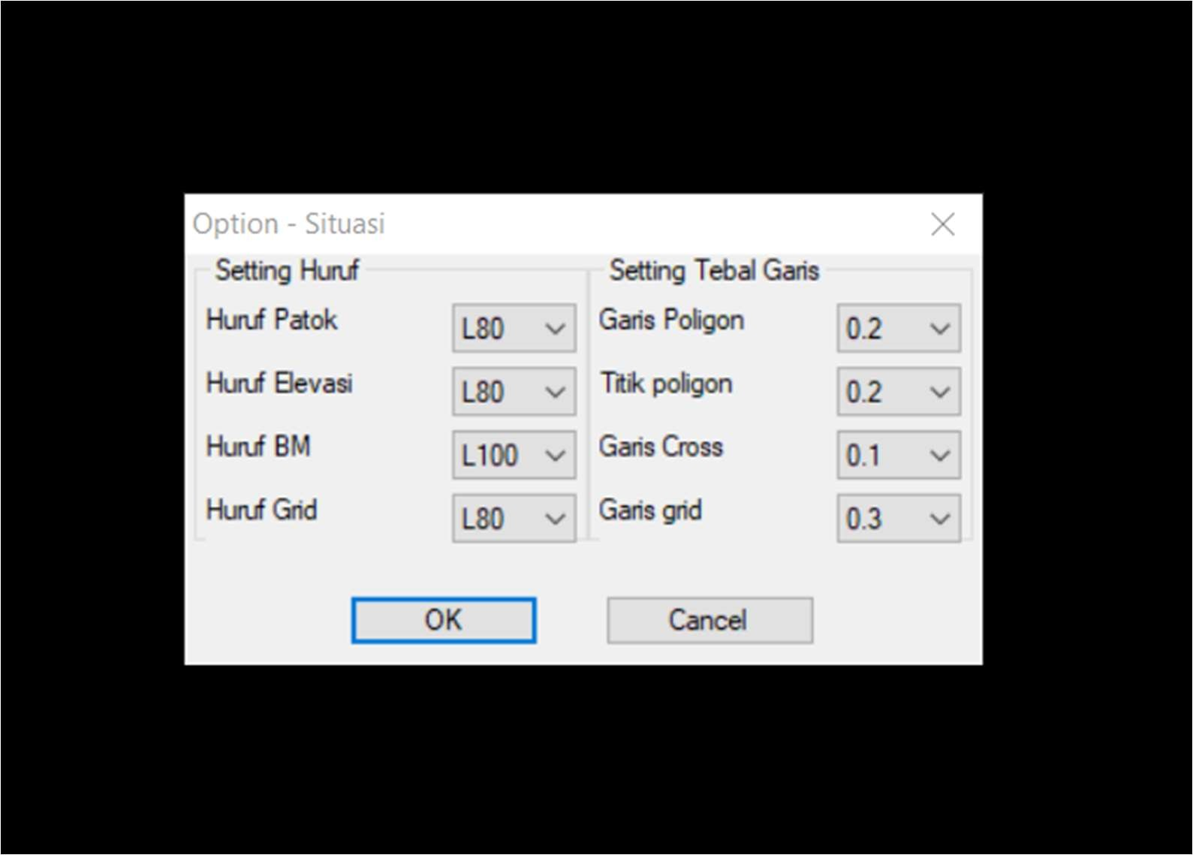

- DEPICTION OF THE SITUATION
The sequence of depicting the situation is as follows:
  - Input topographic data (polygon, cross, situation and BM) to Excel
  - Save the data in .txt format (tab delimited) to the \data\situation directory
  - Running program

Topographic data input
The topographic data format includes polygon data, cross, situation, BM and canal dimension data located in the Data.xls file in the \DI \Data\Data.xls sheet Cross directory
with the following format:
Cross section data

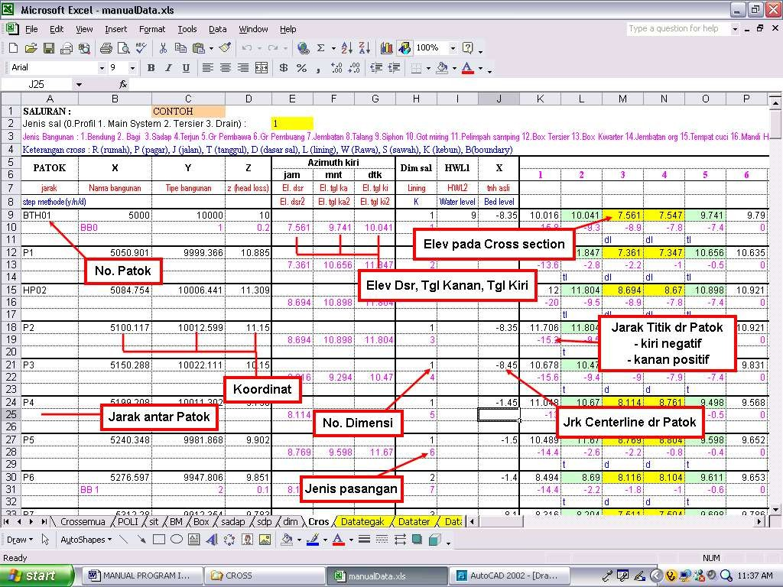

Canal dimension data

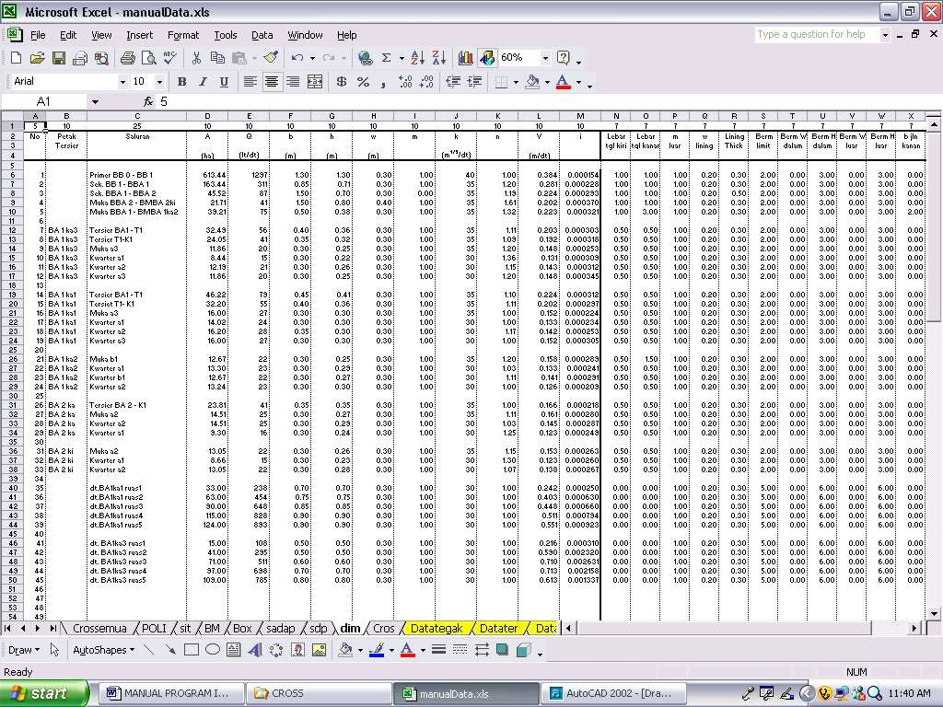

Situation Data
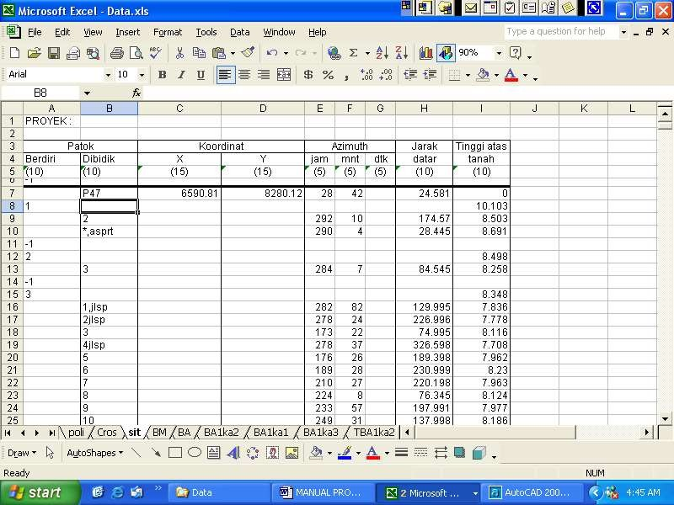

BM Data
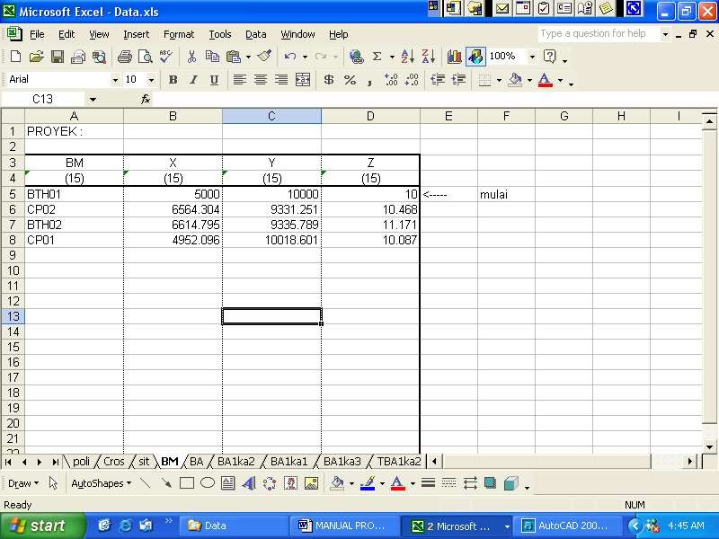

Other menus
In addition to the above menu, there are several other menus in topography, namely the kop menu to insert the kop and the grid menu to draw a grid on the situation map.

- LONG & CROSS CANAL DESIGN DRAWING
For the depiction of canal design there are several things that must be considered:
  - Plan canal dimensions
  - Location, Name, structure type and head loss
  - Water level at the beginning of the canal
  - Location of the canal axle (center line)
  - Pair type

Design data input
There are 2 (two) types of data input that must be done for design drawing, namely:
  - Input canal design data in polygon and cross data files.
  - Input canal dimension data

Canal Design Data

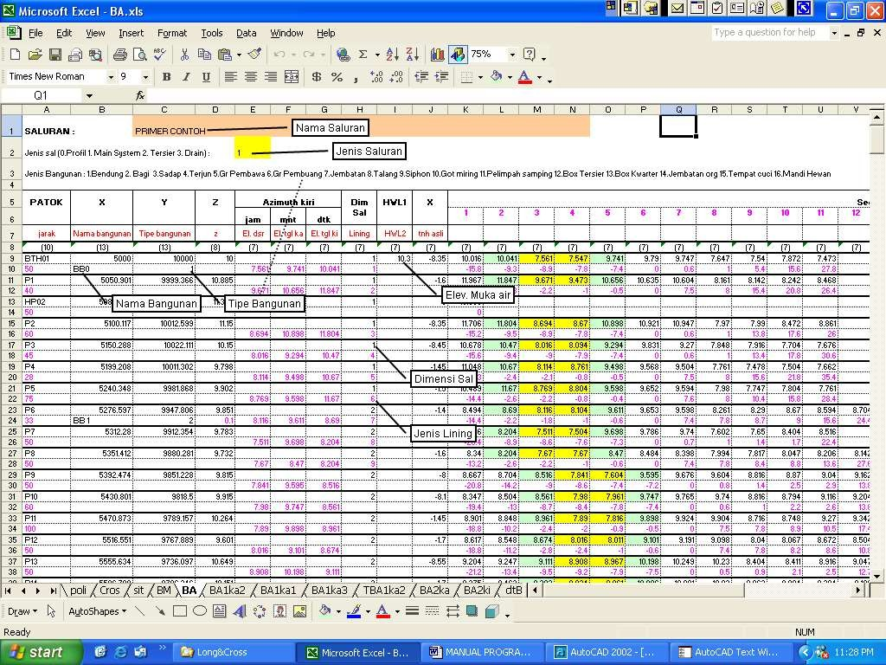

Canal dimension data

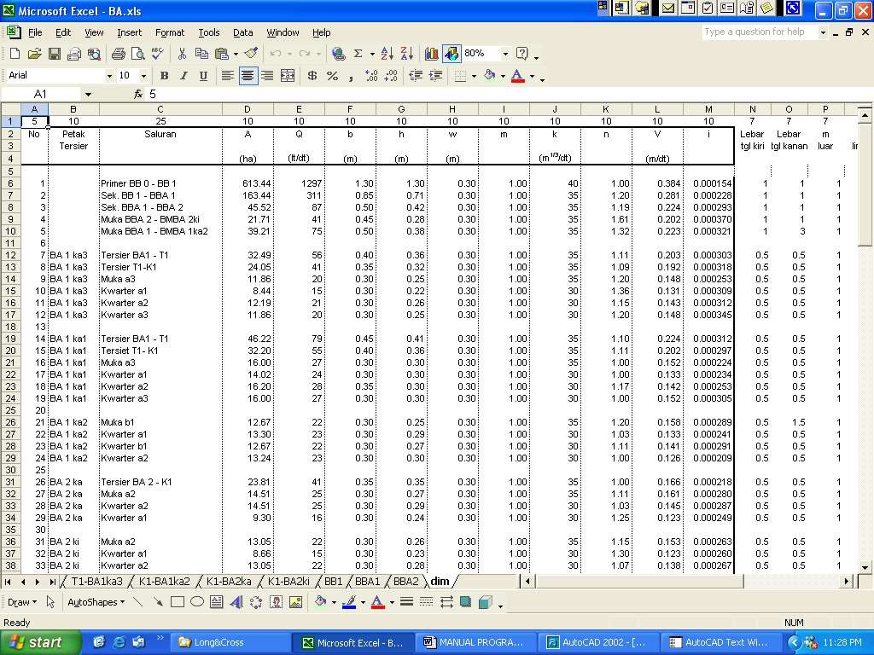
Save the data in .prn format to the \data\Long&Cross directory.

Running design data
design

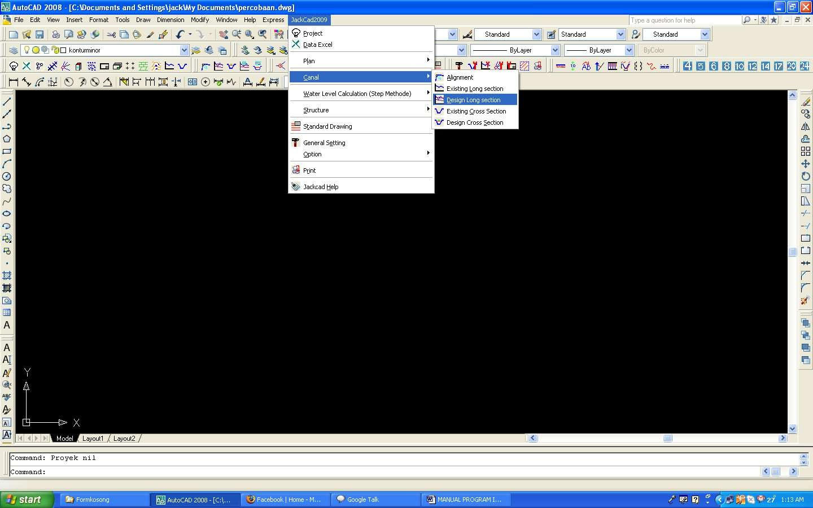
Cross design image
Longitudi nal drawing

Design drawings include longitudinal and cross sections.

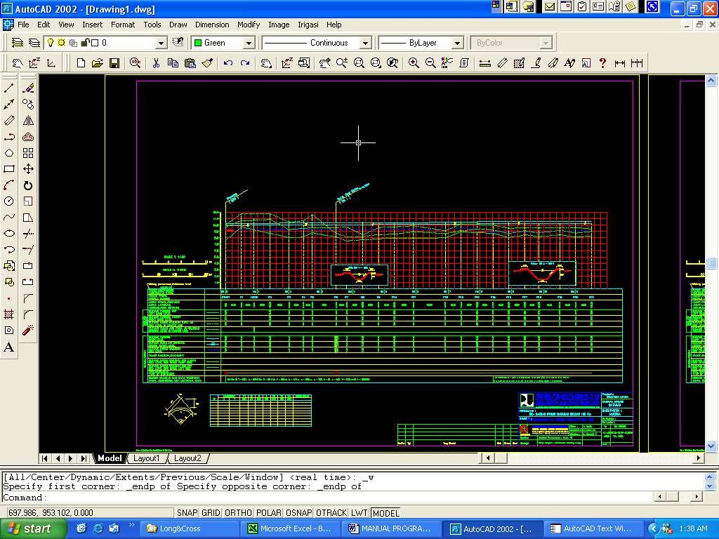

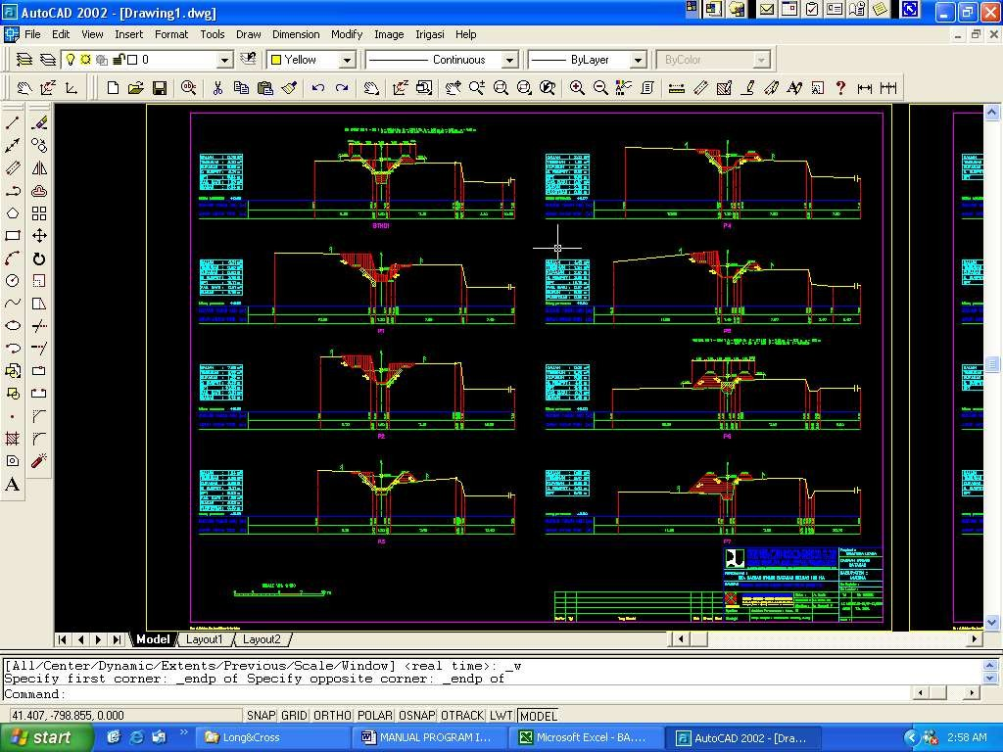

- DEPICTION OF OFF TAKE AND BOX STRUCTURES

For the depiction of the off take structure, the following things must be known:
  - Canal dimensions
  - Door dimensions
  - Culvert dimensions (if any)
  - Dimensions of the plunge structure (if applicable)
  - Original ground elevation
For the depiction of the box structure, the following must be known:
  - Canal dimensions
  - Box dimensions
  - Sill elevation

Data input

Off take structure data

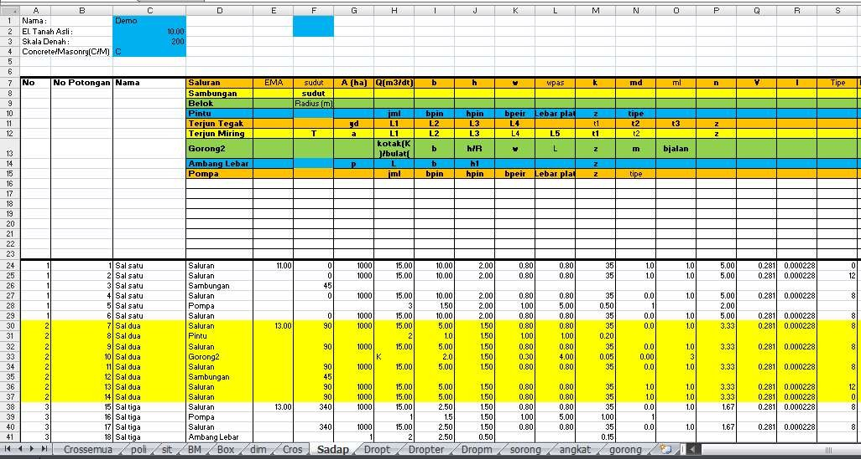

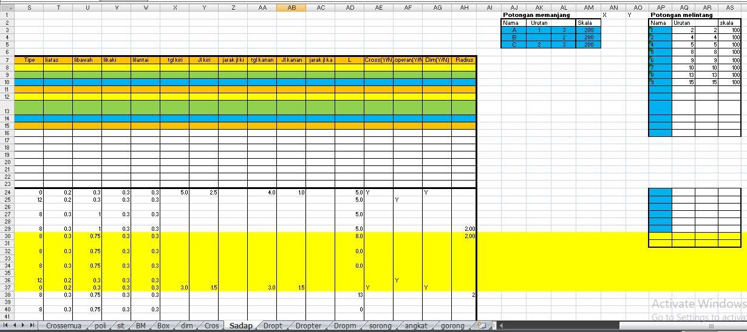

Box structure data

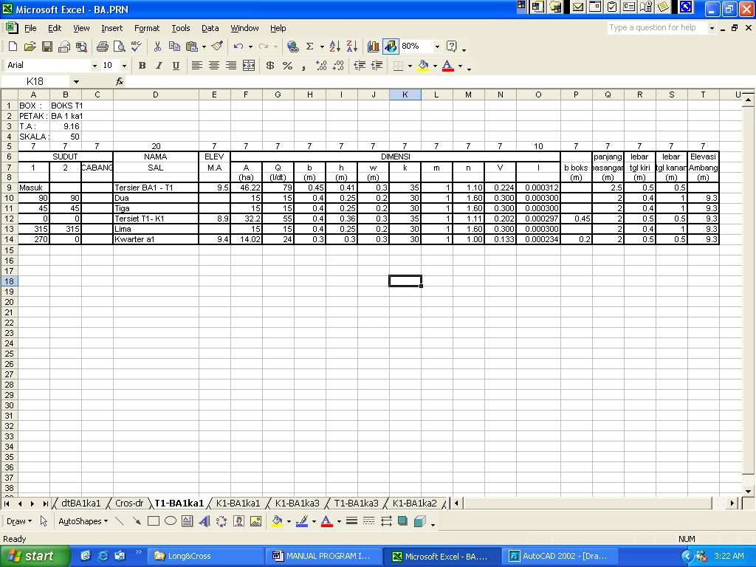

To draw an intake structure is with the command :

Irrigation→ Structures→ Off take
To draw a longitudinal cut is with the command :

Irrigation→ Structure→ Box

- DEPICTION FORMAT

Font and scale settings
For the previous depiction, the font and scale of the image are set in advance so that the printout is in accordance with the depiction standard:
Commandments: Skatul
Available fonts L40 to L500.

PRINTING
For printing to use the plot style table pen as follows: Black A1→ to print black and white A1 paper size Black A3→ for printing black and white A3 paper size A1 color→ for printing in color A1 paper size
A3 Color→ for printing in color A3 paper size Printing can also be done with the "print" command
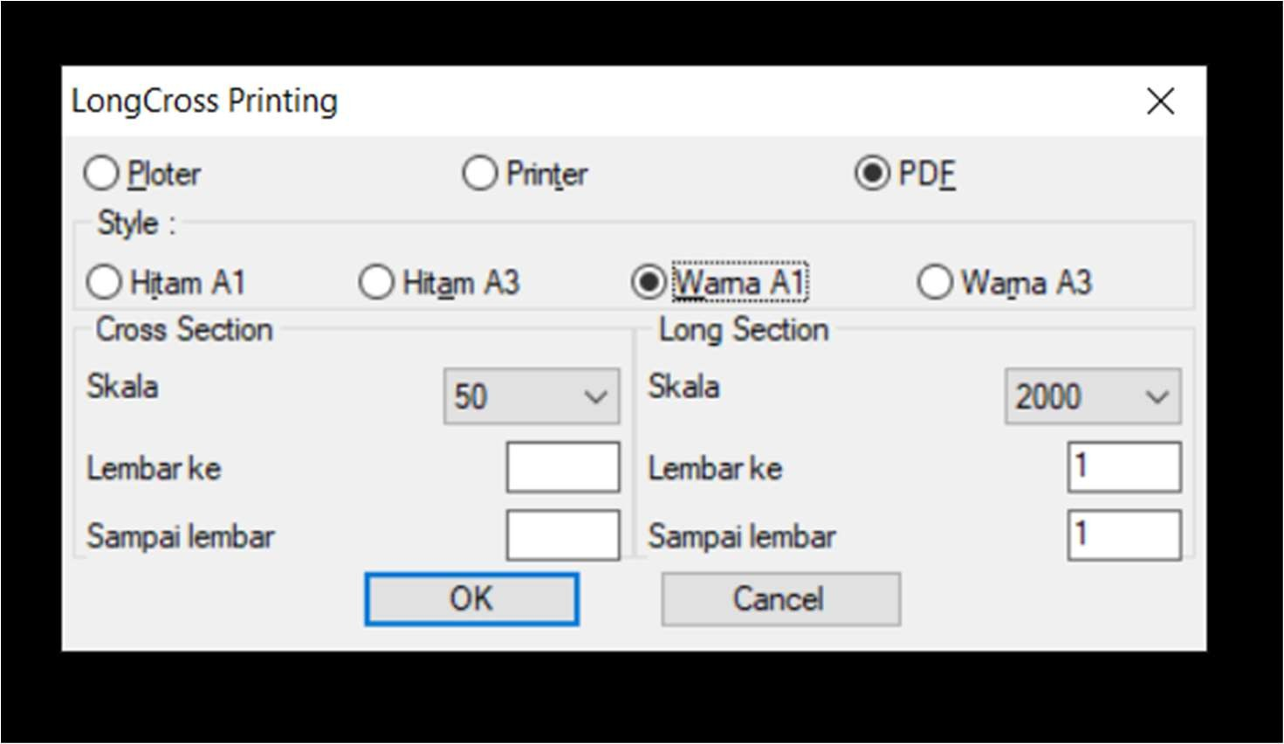

- For drawing in the Jackcad program, both structures and canals, the line thickness is set through the line color as follows:

Setting tebal garis menurut warna

Tebal garis
Warna | 0.1 | 0.2 | 0.3 | 0.4 | 0.5 | 0.6 | 0.7 | 0.8 | 0.9 | 1
Hitam | 1 | 2 | 3 | 4 | 5 | 6 | 7 | 8 | 9 | 10
Merah | 11 | 12 | 13 | 14 | 15 | 16 | 17 | 18 | 19 | 20
Kuning | 21 | 22 | 23 | 24 | 25 | 26 | 27 | 28 | 29 | 30
Hijau | 31 | 32 | 33 | 34 | 35 | 36 | 37 | 38 | 39 | 40
Cyan | 41 | 42 | 43 | 44 | 45 | 46 | 47 | 48 | 49 | 50
Biru | 51 | 52 | 53 | 54 | 55 | 56 | 57 | 58 | 59 | 60
Magenta | 61 | 62 | 63 | 64 | 65 | 66 | 67 | 68 | 69 | 70
Hitam | 71 | 72 | 73 | 74 | 75 | 76 | 77 | 78 | 79 | 80
Coklat | 81 | 82 | 83 | 84 | 85 | 86 | 87 | 88 | 89 | 90

